

Republic of the Philippines
SULTAN KUDARAT STATE UNIVERSITY
College of Computer Studies
Isulan Campus
Isulan, Sultan Kudarat
MIDTERM EXAMINATION
PATHFit 3
Name:_____________________________________ Course, Yr, and Sec: _________Score:___________
General Directions: This examination is good for one hour. Read and analyze each item carefully.
TEST I. Multiple Choice. Read and analyze each test item. Write the letter that corresponds to the correct answer on the space provided before the number.

_______1. A dance developed by people that reflect the life of the people of a certain country or region.
- Folkdance c. Dancing
- Dance d. Ritual Dance
_______ 2. It is to express one’s emotions through movement disciplined by rhythm.
- Ethnic dance c. Dance
- Dancing d. Folkdance
_______ 3. It is a series of movements set to music where there emerge organization, structure, and pattern.
- Ethnic dance c. Dance
- Dancing d. Folkdance
_______ 4. These are special dances which are mimetic in nature.
- Occupational dance c. Life-cycle dance
- Mimetic dance d. Ritual dance
_______ 5. It evolved from the simplest rituals used by the hunters to find their prey.
- Spanish-colonial period c. American-colonial period
- Primitive era d. Ancient Egypt
_______ 6. They are called “medicine men” of primitive cultures whose powers are to invoke the assistance of a God.
- Babaylan c. Priest Dancer
- Anito d. Zumba Instructor
_______ 7. It is a cultural art form which is handed down from generation to generation. It also communicates the customs, beliefs, rituals and occupation of the people of a region or country.
- Ethnic dance c. Hip-hop
- Foreign Dances d. Folkdance
_______ 8. What era was dance performed in cathedral porches, church squares, and market places, miracle plays, mystery plays and morality plays that taught the church’s lessons were enacted in a theatrical way?
- Spanish-colonial period c. Christian Era
- Primitive era d. Ancient Egypt
_______ 9. Participation in dance and drama festivals was a religious exercise, not merely an amusement.
a. Primitive era c. Ancient Greece
b. Roman Empire d. Ancient Egypt
_______ 10. Are dances which celebrate an individual’s birth, baptism, courtship, wedding, and demise.
a. Mimetic Dances c. Occupational Dances
b. Life-cycle Dances d. Ritual Dances
_______ 11. These are dances which transform defense and livelihood activities to celebratory performances.
a. Mimetic Dances c. Occupational Dances
b. Life-cycle Dances d. Ritual Dances
_______ 12. What dances were found among ethno-linguistic groups scattered all over the Philippine Islands, who have not been substantially westernized, either by Spain or the United States?
- Folkdance c. Hip-hop
- Foreign Dances d. Ethnic dance
_______ 13. She is considered as “Mother of Philippines Folk Dance”.?
- Francesca Reyes-Aquino c. Alice Reyes
- Ramona Obusan d. Lucresia Reyes-Urtula
_______ 14. A fast walk, weight is being transferred from one foot to another with weight carried forward on the ball of the floor.
a. Running c. Leaping
b. Skipping d. Galloping
_______ 15. A spring on one foot and landing on the other foot.
- Jumping c. Hopping
- Skipping d. Leaping
_______ 16. Moving part of the body around a long axis, usually head and body.
- Twist c. Swing
- Raise d. Turn
_______ 17. Movement of body part that can push ahead and in reverse or side to side.
a. Twist c. Swing
b. Raise d. Turn
_______ 18. It is an effort to move an object, real or imaginary, is space away from the body against resistance.
- Pushing c. Pulling
- Lifting d. running
_______ 19. Change of body level or any part of the body or an object, real or imaginary, from a lower to a higher level.
- Pushing c. Pulling
- Lifting d. Switching
_______ 20. It is performed in connection with religious vows and ceremonies.
a. Religious Dance c. Festival Dance
b. Wedding Dance d. Comic Dance
_______ 21. This dance is suitable for special occasion or any social gathering.
a. Game Dance c. Ceremonial Dance
b. Festival Dance d. Wedding Dance
_______ 22. The foot that bears the weight of the body’s couples.
- Supporting hand c. supporting foot
- Free foot d. free hand
_______ 23. Point the right foot the left foot; bend knees slightly.
- Curtsy c. Pivot
- Dos-a-dos d. Do-si-do
_______ 24. To display quickly one foot with the other, thus completely talking off the weight of the body from the displaced foot.
- Curtsy c. Pivot
- Dos-a-dos d. Cut
_______ 25. Bend arms in front of the chest and put one fore arm on top of the other.
- Folded arms c. Jaleo
- Hapay d. Pivot
_______ 26. Turn the hand around from the wrist counter clockwise then raise the lower wrist once or twice. This is an Ibanag term.
- Bilao c. Kumintang
- Masiwak d. Salok
_______ 27. To turn with the ball, heel, or whole foot, on a fixed place or point.
- Folded arms c. Jaleo
- Hapay d. Pivot
_______ 28. Both arms raised sideward, elbow, bent so that the forearms are raised upward to the head Palms facing in.
- Reverse T-Position c. T-Position
- Costados d. Brush
_______ 29. To advance or recede by raising or moving one foot to another resting place. There is complete transfer of weight from one foot to another.
- Hands on waist c. T-Position
- Costados d. Step
_______ 30. To flourish or offer a handkerchief, hat or glass or wine to somebody as a sign of invitation.
- Masiwak c. Gayong-gayong
- Costados d. Hapay
_______ 31. The foot nearest one’s partner when partners stands side by side.
- Inside Foot c. Jaleo
- Hapay d. Pivot
_______ 32. Partners turn once around clockwise (with R elbows almost touching) or
counterclockwise (with L elbows almost touching) using walking or any kind of dance step.
The hands near each other are on waists. This is a Tagalog term but of Spanish origin.
- Inside Foot c. Pivot
- Hapay d. Jaleo
_______ 33. Moving the hand from the wrist either in clockwise or counter clockwise direction. This is an Ilocano term.
- Bilao c. Kumintang
- Masiwak d. Salok
_______ 34. The foot not bearing the weight of the body.
a. Left Foot c. Free Foot
b. Right Foot d. Outside Foot
_______ 35. The following are do’s in folkdance except;
- Dance with exertion and arduousness.
- Use the proper costume for the dance.
- Follow directions and dance instructions as closely as possible.
- Dance with feeling and expression
_______ 36. Arms: both arms raised forward to form a circle in front of the novel. Feet: both heels close together, toes are apart with an angle of about 45 degrees. What position in folkdance is this?
- 1st arms and feet position
- 2nd arms and feet position
- 3rd arms and feet position
- 4th arms and feet position
- 5th arms and feet position
_______ 37. Arms: both arms raised over the head. Feet: heel of front foot close to big toe of rear foot. What position in folkdance is this?
- 1st arms and feet position
- 2nd arms and feet position
- 3rd arms and feet position
- 4th arms and feet position
- 5th arms and feet position
______ 38. Arms: one arm raised sideward as in 2nd position other arm raised overhead. Feet: heel of one foot close to in step of the other foot. What position in folkdance is this?
- 1st arms and feet position
- 2nd arms and feet position
- 3rd arms and feet position
- 4th arms and feet position
- 5th arms and feet position
_______ 39. Arms: right arm position in front of the chest in half circle. Left arm raised over the head. Feet: Right foot step in front. Left foot stay at the back of right foot with the pace distance. What position in folkdance is this?
- 1st arms and feet position
- 2nd arms and feet position
- 3rd arms and feet position
- 4th arms and feet position
- 5th arms and feet position
________ 40. Arms: both hands raised sideward with a curve level in waist. Feet: a stride sideward of legs about a pace of 1 foot distance. What position in folkdance is this?
- 1st arms and feet position
- 2nd arms and feet position
- 3rd arms and feet position
- 4th arms and feet position
- 5th arms and feet position
TEST II. IDENTIFICATION. Study and Identify the following pictures below. Write your answer on the space provided.
41. _________________________ 44. ______________________
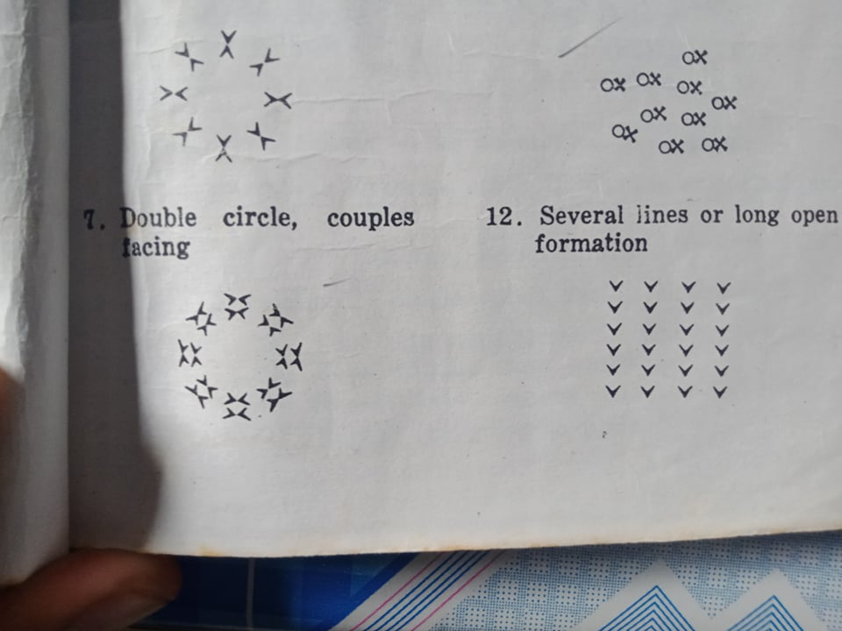

42. ______________________________ 45.
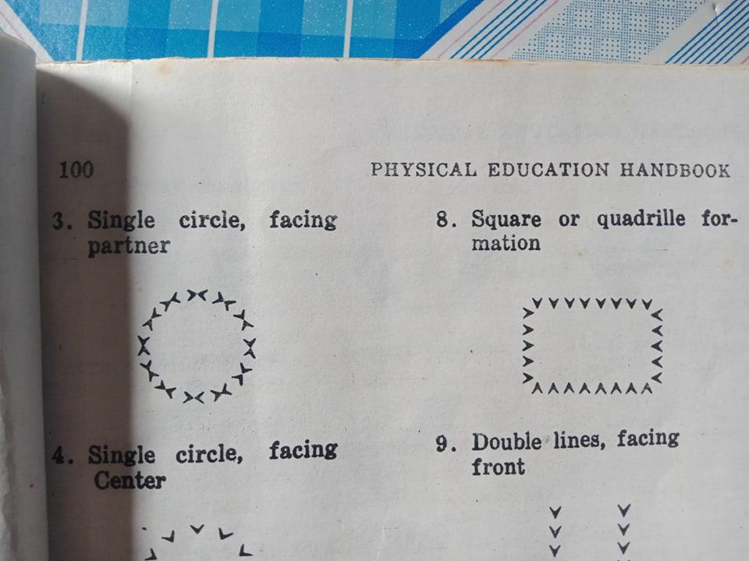
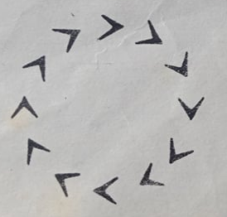

43. _____________________________

TEST III: Enumeration
46-50. What are the Do’s in Folk dancing
51-55. What are the Dont’s in Folk dancing

TEST IV: Essay (15 points)
How do Philippine Folk dances reflect the country’s cultural identity and heritage?

Prepared by:
MAY C. GALLANO, PhD

